January 2017

Dear Merchistonian

I write to provide you with information on our activities for 2017.

SUBSCRIPTIONS/MEMBERSHIP

The Club needs your support through subscriptions, and I am pleased to say that they remain at the previous levels:

Suggested Subscription for 2017 | £40
Suggested Subscription for U25s on 1 January | £10
Suggested Subscription for U21s on 1 January | FREE

As well as sending a cheque, you can also pay direct or set up a standing order. Payments can be made electronically using the following details:

Name: Merchistonian Golf Club
Account: 11771709
Sort Code: 83 - 51 - 00
Bank: RBS, 142-144 Princes Street, Edinburgh EH2 4EQ
Reference: Please state you name

The Membership Form (attached) should be returned to me (either at 4 Lygon Road, Edinburgh EH16 5QE or by email to robert.forman@brodies.com) along with your Subscription Cheque (or confirmation of Payment).

Please do feel free to give more if you are able and please do try to encourage other Merchistonians to get involved – plenty of golf, at great courses and at a reasonable price.

2017 FIXTURES

The Fixture List for 2017 is enclosed with the usual matches against other schools at Muirfield, Panmure and Prestwick. Please indicate your interest in playing by returning the list to me with your choice, or by simply emailing me and telling me.

INAUGURAL MERCHISTONIAN “HOLE IN HOLE”

The Spring Meeting for the past few years has seen a decline in attendance due to a number of reasons. The Committee has therefore decided to replace the Spring meeting with an ongoing “hole in hole” tournament that it is hoped that many of you will participate in. Such an event should allow matches to be played at a time that is suitable to both players and provide a focus for the Club through the Spring and Summer in the run up to the Autumn Meeting. Yes, it is acknowledged that Merchistonians live far and wide, but it is hoped that many will participate with an element of common sense prevailing in arranging the ties! Interested participants should email me (the Secretary) when

they return their membership form and their match availability. The rules will be similar to many “hole in hole” competitions at your own golf clubs: ties to be played on time, the person on top
is the challenger, three dates must be given (one at a weekend) and it is full handicap allowance. The winner will be presented with their trophy at the Autumn Meeting. All sounds very easy – so please join in.

AUTUMN MEETING

The Autumn Meeting will be held at Bruntsfield Links Golfing Society on Saturday 26 August. It is a much earlier date this year due to the host club having conflicting commitments but the success of the past two years made it an easy decision to go back to Bruntsfield. Accordingly, there will be a BBQ, then a Shotgun start in the afternoon followed by dinner.

I look forward to hearing from as many of you as possible.

Head up, swing fast!

Yours sincerely

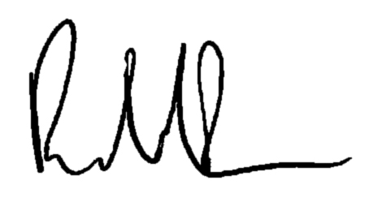
Robert A. Forman
robert.forman@brodies.com

