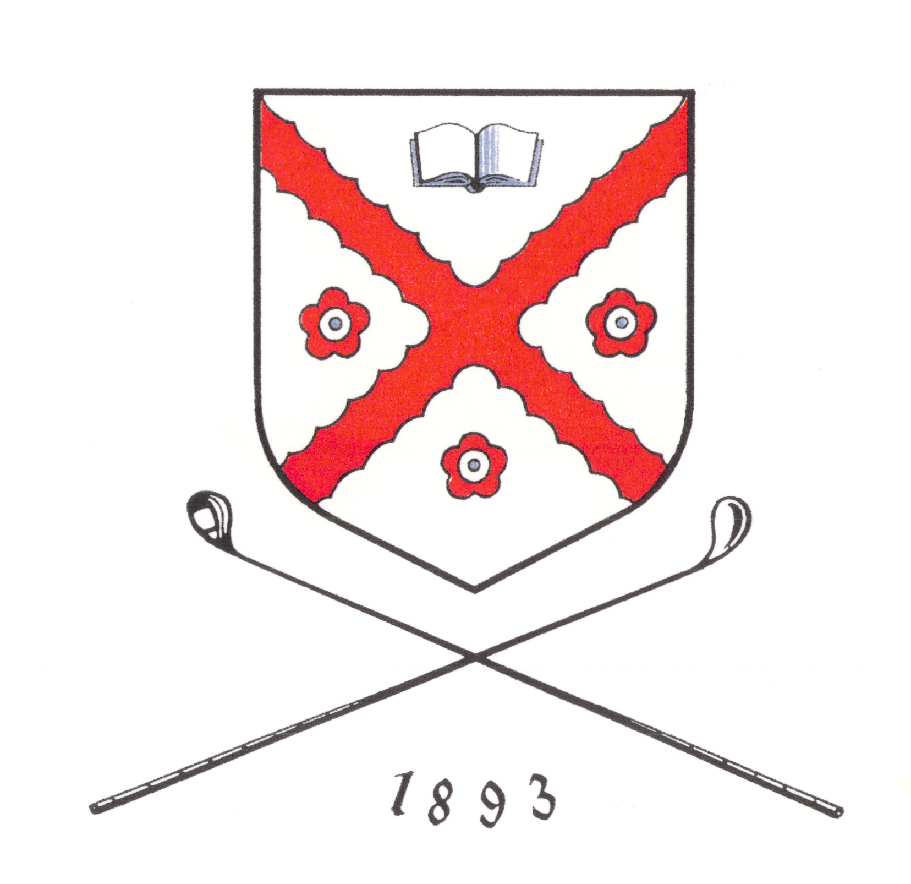

HCEG vs MCS

18 June 2017

------------------------------------------------

Chris Cowan & Harry Thomson

Vs

Calum M &Charlie Y

Roger Baird & Nick White

Vs

Ronan D & Rory T

Gavin Thain & Alastair Milligan

Vs

Cameron A & Papon S

